St Mary’s Parish
Magazine

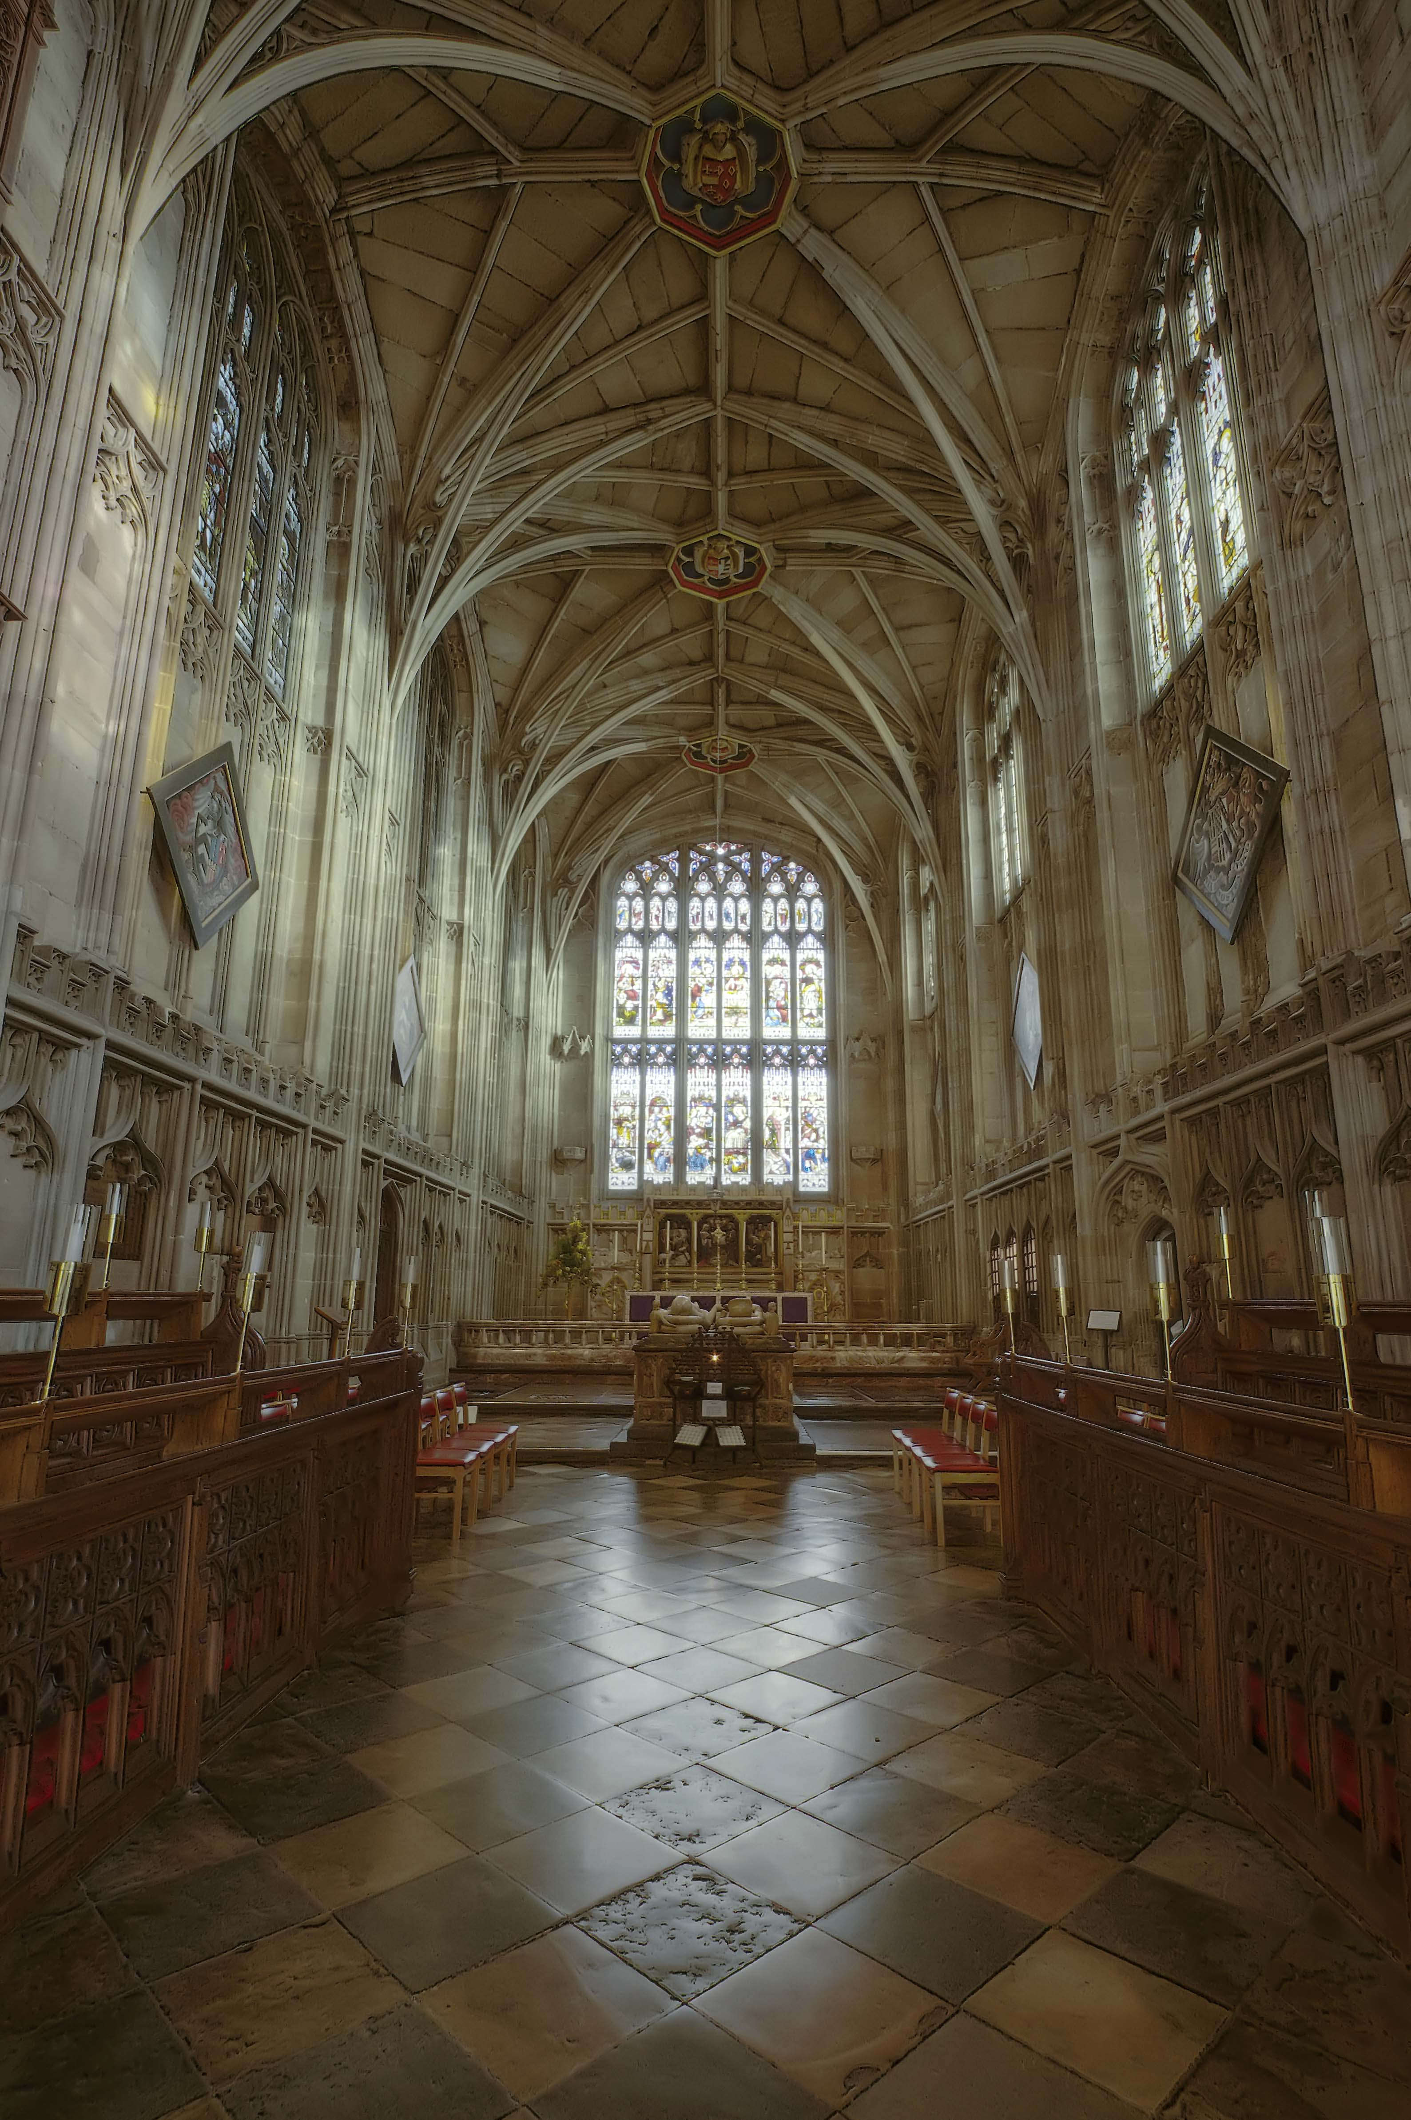

January - February 2018

50p
Notes from the Editor  So another year has come and gone, and what are you going to do to start the new year off?  Begin by making some New Year's goals. Dig within, and discover what you would like to have happen in your life this year. This helps you do your part. It is an affirmation that you're interested in fully living life in the year to come.  Goals give us direction. They put a powerful force into play on a universal, conscious, and subconscious level. Goals give our life direction.  What would you like to have happen in your life this year? What would you like to do, to accomplish? What good would you like to attract into your life? What particular areas of growth would you like to have happen to you? What blocks, or character defects, would you like to have removed?  What would you like to attain? Little things and big things? Where would you like to go? What would you like to have happen in friendship and love? What would you like to have happen in your family life?  What problems would you like to see solved? What decisions would you like to make? What would you like to happen in your career?  Write it down. Take a piece of paper, a few hours of your time, and write it all down - as an affirmation of you, your life, and your ability to choose. Then let it go. | Contents  3 Reflections From The Rectory  The Rector looks ahead to this year’s Lent  addresses  4 Celebrating Saint Paul  Such an important character gets more than  one celebration in the year  5 Time to Face the Music!  Leamington Music’s early music concert series  continues  6 A New Year Perspective  Looking ahead to the new year in a spiritual way  8 Never A Crossword  Our regular brain teaser with mainly biblical  themes  9 Thought For Food  A simple but tasty winter recipe  10 Good Luck and Bad  Some local folklore  12 What Is A Success In Africa  Dirk Juttner reports on a recent visit to the CMM  Sisters in Masasi  14 Poets Corner  A poem for winter  15 Facebook For The Senior Generation  A quick update on modern technology  15 And Finally ……  Crossword answers and other important things  
Footnote:
Copies of the magazine can be posted to your home or friends and relations. Subscription rates are
£6.50 for a year (6 editions), including postage. Please contact the Parish Office.

2
REFLECTIONS FROM THE RECTORY
The 2018 Lent Addresses are finalised to start in February, exploring one of our key areas for development in the Natural Church Development programme – how we understand and read the Bible. It is a fascinating series, with excellent speakers:

The Bible
- Past, Present, Future –

18th Feb The Bible in Worship
Stephen Platten
formerly Bishop of Wakefield and Dean of Norwich
Author of Animating Liturgy and Rebuilding Jerusalem
25th Feb The Bible in the Reformation
Peter Marshall
Professor of History at the University of Warwick
and author of Heretics & Believers
4th Mar The Bible Now
Sharon Jones
Chaplain at the University of Birmingham, honorary lecturer in Theology & Religion and writer of Young Adult fiction
11th Mar The Bible as Great Art
Trevor Dennis
formerly Vice Dean of Chester Cathedral
Author of God in Our Midst and The Gospel Behind the Gospel
18th Mar The Bible: From Papyrus to Pixels
Hugh Houghton
Director of the Institute for Textual Scholarship & Electronic Editing, University of Birmingham and widely published author.
Each Address is part of Choral Evensong followed by a Q&A.
It’s a great series and I do hope you are able to come along
Vaughan
The Revd Vaughan Roberts

3
CELEBRATING SAINT PAUL

St Paul has more than one feast day, and 24 January is the Eve of his Conversion to Christianity. Late January was not a popular time for traditional festivals, presumably because it was too soon after the Christmas/New Year period, but a range of related customs, each concerned in some way with broken crockery, was reported from Cornwall in 1886 by the Folk-Lore Journal, including the following:

St Paul’s Eve is a holiday with the miners, and is called by them Paul Pitcher Day, from a custom they have of setting up a water-pitcher, which they pelt with stones until it is broken in pieces. A new one is afterwards bought and carried to a beer-shop to be filled with beer.

In other examples, but from a similar period, children roamed the streets throwing broken crockery at people’s doors, or into their hallways. The Western Antiquary records:

On entering a house, I have, more than once, stumbled over the broken pieces of a ‘Paul’s pitcher’.

The motive of throwing broken crockery at doors has no rational explanation!

St Paul was important enough in Church history to receive more than one feast day; 29 June is his main day, shared with St Peter, while 25 January commemorates his conversion to Christianity on the road to Damascus.

In the secular sphere, it was said that the weather on this day was an excellent guide to the prevailing character of the coming year. In most cases, the prognostication simply refers to weather and harvest - ‘If St Paul’s is fair and bright the harvest will be good’ – but some took the prediction into weightier realms, as in the following Cornish example recorded in the Western Antiquary in 1884:

If Paul’s Fair be fair and clear
We shall have a happy year
But if it be both wind and rain
Dear will be all kinds of grain
If the winds do blow aloft
Then wars will trouble this realm full oft
If clouds or mist do dark the sky
Great store of birds and beasts shall die.

4
TIME TO FACE THE MUSIC!

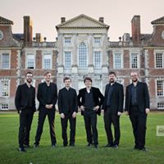
The monthly BAXI Early Music Concerts season put on by Leamington Music at St Mary’s continues on Tuesday 23 January when the Gesualdo Six appear in Warwick for the first time. This young group of professional singers which is directed by Owain Park look set for a starry future. Its programme The Flower of the Italian Madrigal has sacred and secular music from Italy’s Golden Age of Music with Monteverdi, Lassus and Gesualdo among over a dozen composers represented. Those who enjoyed all the Monteverdi in the stunning opening concert of the season from Ex Cathedra in October will know what to expect. If you missed that, don’t miss this one!
The concert on 20 February sees the return of Joglaresa, a regular visitor to this series since it was launched in 1996. Directed by singer Belinda Sykes who also plays the bagpipes – other instruments featured besides percussion include fidel, harp and dulcimer – the new programme The Enchantress of Seville explores the roots of flamenco, Arabic ballads, Judeo-Spanish romanzas and ancient Christian chant.
The final concert of the season on 13 March moves into the Classical period. The Bach Players directed by Nicolette Moonen with soprano Rachel Elliott will bring Music for Easter with the Stabat Mater of Boccherini as the central work. He is known to us all by the most haunting of all minuets ever written and his Quintet for Guitar and Strings has been programmed here quite often. The Stabat Mater dates from 1781 and there are also movements from Haydn’s Seven Last Words on the Cross and a cantata by Johann Fischer (1646-1716), so writing when St Mary’s was being renovated after the Fire of Warwick.

Tickets from £13 are available at the St Mary’s Church Gift Shop or call 01926 334418. Online bookings and full details through www.leamingtonmusic.org

5
A NEW YEAR PERSPECTIVE

As Christmas comes to an end we anxiously await the words "Happy New Year!" My best friend and I have this tradition we do every year for the last five years usually around the end of December. We go to our favourite spot, where we talk and pray about the past year and look ahead to the New Year. We ponder and discuss all the interesting occurrences that happened the past year; the good times, the bad times, the frustrating times and the fun times. We share what valuable lessons we learned from our experiences, what God showed us and how He was faithful through all of it.
We do this as a closure to one year and then an opening to the next. After we have laughed a while and then cried, we begin to look forward with great excitement, wondering what God has for us this coming new year. What new experiences will we go through and what new lessons will we learn. It's all fresh and new and that is exciting. In doing this I believe it helps us to view each year as a season, understanding that God is Sovereign and has new seasons of experiences and growth to make us more like Christ. I can testify there were times we went through seasons of grief and there were also times we experienced seasons of joy.
It helps me to remember that God is in total control and that we are constantly growing as His children and that He knows the plans He has for us. Plans of new wisdom, insight and understanding that He wants to impart to us, if we will allow Him to. It also gives us a fresh new outlook of the coming year and enables us to leave the past where it belongs, not that we forget the past but learn from it and move forward into our present future with opened hearts and minds to receive whatever God has for us.
With that said, I put together eight ways we can view the New Year and every year as a year of:
New Beginnings: Start out the New Year with a fresh point of view to new experiences, memories and blessings. Having an opened mind and heart to where ever the Lord may take you with full assurance and confidence that He is with you. (Matthew 28:19-20)
New Possibilities: There's no limit to what God can do in your life and nothing is impossible with God. God opens doors that no man can shut
6
and also closes doors that no man can open. The possibilities are endless with God that is according to His will. (Philippians 4:13)
New Plans: Every year is a new season, be prayerful of what God has planned for you and be willing to walk by faith in obedience as you follow His leading. Remember that His plans are always for good and not for evil to give you a future and a Hope. (Jeremiah 29:11-13)
New Purpose: As you forge ahead, God always has a plan and a purpose for what you will go through and experience. Remember that God always has a reason for what He allows in your life and through it you can trust Him completely. (Proverbs 1:3-5)
New Provisions: The bible says to not worry about tomorrow for tomorrow has enough worries of its own. Trust in your Heavenly Father who knows everything you need, who is your God and your Provider. He is faithful and He will do it. (Matthew 6:1-33)
New Growth: When we are willing to let go and let God work in us and through us, He will always stretch us and grow us. It is an important part of the growth process. Continue to grow in your relationship with Him and in His Word. Pray for God to mould you and make you pliable in the potter’s hand and then watch the master craftsman work on His masterpiece; which is you!
New Wisdom: With new experiences and new lessons come new wisdom and insight. Always make it a priority to seek out wisdom as hidden treasure or fine gold. In Proverbs it says that it will be like a garland of grace around your neck and honour you and present you with a crown of splendour. (Proverbs 4:7-9)
Renewed Peace: As you go through new experiences and new adventures whether they are good or bad, my encouragement is to keep your eyes fixed on Christ and He will give you rest and peace, because He is our peace and loves you and cares for you deeply. (John 16:33)
Let us give thanks to the Lord for getting us through another year as we look forward to what He has for us up ahead and praise Him that He is faithful and worthy to be praised!
Filoiann Wiedenhoff

7
NEVER A CROSS WORD!

 | 1 | 2 |  | 3 |  |  |  | 4 | 5 |  | 6
7 |  |  |  |  |  |  | 8
9 |  |  |  |  |  |  |  |  | 10
11 |  |  |  |  | 12 |  | 13
 | 14 |  | 15
 |  |  |  |  |  |  |  |  |  | 16 |  | 17
18 |  |  |  |  |  |  | 19 | 20
21 |  |  |  |  | 22
23 |  |  |  |  |  |  | 24

ACROSS  1. Capacity of a cardinal and his vestment. (5)  4. Proclamation of one hundred tied in knots. (5)  9. Gospel preachers finding Leo’s past dubious. (8)  10. Prime Minister in the garden. (4)  11. Goods supplied for ordination? (6)  13. Biblical town where Austen heroine met you and me. (6)  15. Mad Carmen claims right to be a reforming Archbishop! (7)  18. Seat collapsed on the queen at festival. (6)  19. Coned off around a clergyman. (6)  21. Holy man, upper-class, sends note to horse breeder. (4)  22. Chief clergyman? (8)  23. Mixed up girl left behind at St Lawrence’s resting place? (5)  24. Old king serves a winner, it’s said, before dinner. (5) | DOWN  2. Trousers, say, for organists? (6)  3. Safe saint. (5)  5. Joseph remade, remade king! (7)  6. Putti grooming her cubs? (7)  7. Clergyman as a rule. (5)  8. Highly regarded, Dee meets up. (8)  12. Hard cash converted and put in a furnace. (8)  14. Group of clergy taken to book? (7)  15. El Cid volunteers to find somewhere for the Salvation Army. (7)  16. 99 on 99 – it’s venerated! (6)  17. Bent messenger? (5)  20. Tree for a Scottish churchman. (5)

8

THOUGHT FOR FOOD

Italian chicken with courgette rice  A simple but tasty winter recipe  Ingredients  - 1tbsp olive oil  - 4 chicken breasts  - 500g (1lb2oz) fresh Italian tomato & basil sauce  - 3 yellow peppers, sliced  - 300g (10oz) long grain white rice  - 2 courgettes (approx 300g/10oz), grated |   Preparation: 10 minutes  Cook: 30 minutes  Serves 4
Heat the oil in a large frying pan and brown the chicken on each side for 2-3 minutes until golden. Remove from the pan and set aside. Add the pepper to the pan and stir fry for 10 minutes until softened. Pour over the tomato sauce and bring to the boil. Place the chicken in an ovenproof dish and pour over the peppers and sauce. Transfer to the oven and bake for 15 minutes until the chicken is cooked through with no pink showing.
Meanwhile bring a pan of water to the boil, then add the rice and simmer for 15 minutes until tender. Stir through the courgette and serve with the chicken and peppers.
Serve with a chilled Pinot Grigio or other dry Italian white wine.

9
GOOD LUCK AND BAD

It was unlucky to meet a white horse without spitting at it. For a man to meet a squinting man was also unlucky, but a squinting woman was a sign of good luck. It was lucky to see the first lamb of the season facing you, but unlucky to see it tail first. Other lucky encounters were with a chimney sweep, provided that you spoke to him, a sailor, if you touched his collar, or a load of hay, when you needed to wish, and watch it out of sight. To see a piebald or skewbald horse was also a sign of good luck. (A piebald horse, by the way, is a white one with black patches, and a skewbald is white with patches of any colour other than black.) To see three magpies was lucky, but to see one, or any number flying from right to left, was unlucky, unless you crossed yourself or removed your hat. The cuckoo was traditionally held to come to Warwickshire on 17 April. Heard on the left hand, he brought good luck, on the right, bad luck, throughout the year. You should also wish, on first hearing the cuckoo, or alternatively borrow two half-pence, for luck. The old half-penny piece went out of circulation many years ago, and I am not sure whether the belief has transferred to the new currency.

It was thought that the cuckoo changed into a sparrowhawk during the winter, and there are many other beliefs about birds. For example, it was believed that the yellow hammer drank three drops of the devil’s blood each May morning. The crossbill was thought to have acquired his misshapen beak by trying to pull the nails out of Christ’s hands as he hung on the cross. The wagtail was known as the gypsy bird: ‘if you see a wagtail a gypsy won’t be far away’. It was unlucky to kill an owl, and the cry of the screech owl was thought to be a warning of death. To make them be kind to the poor, children were often told this story, which Ophelia refers to in Hamlet:

Our saviour went into a baker’s shop where they were baking, and asked for some bread to eat. The mistress of the shop

10
immediately put a piece of dough into the oven to bake for him, but was reprimanded by her daughter, who, insisting that the piece of dough was too large, reduced it to a very small size. The dough, however, immediately afterwards began to swell, and presently became a most enormous size. Whereupon the baker’s daughter cried out, ‘Heugh, heugh, heugh!’ – which owl-like noise probably induced our saviour, for her wickedness, to transform her into that bird.

The pigeon - or almost any bird, for that matter – brought a warning of death if it dashed itself against the window of a house. It is also the most untidy nest-builder. It is said to have grown tired when the wren gave a lesson in nest-building, so it flew away, crying ‘That’ll do-o-o-o, that’ll do-o-o-o’. People thought that if hair cuttings were carried away by birds and built into a nest, as the nest rotted, the hair would fall from the head of the person to whom the clippings originally belonged. Apart from legends and beliefs about birds, there was a wide range of local Warwickshire names – buttermilk can (long-tailed tit), Jack squeaker (swift), thrice cock (mussel-thrush), and Grecian (yellow hammer, so-called because of the markings on its eggs). Shakespeare used the local word for a heron when he wrote, ‘I know not a hawk from a handsaw’. It was believed that:

He that hurts a robin or a wren
Will never prosper on sea or land.

Another version of the rhyme runs:

The robin and the wren
Are God Almighty’s cock and hen;
The martin and the swallow
Are God Almighty’s bow and arrow.

The robin’s breast was said to have been scorched by hell-fire when it brought a beak of water to give Christ on the cross.

Roy Palmer

11
WHAT IS A SUCCESS IN AFRICA ?

Success in Africa is not rare though that is the impression the media, with its emphasis on bad news, always gives. We want instant success these days but in Africa things take time. As they say: “You have clocks, we have time”.

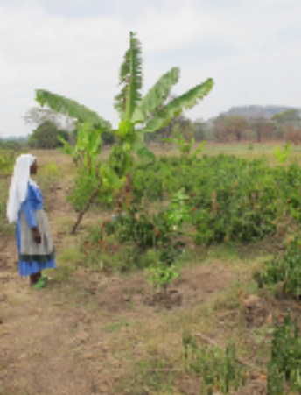
The reasons for this are manifold. Often it is because the people have to rely on the weather for survival, living on agriculture. The customary weather pattern is becoming more and more unpredictable.

There are also many other reasons and sometimes it is even us Europeans thinking we have the answer for getting quick results without consulting the local people.

This year however I experienced two great successes when visiting the CMM Sisters in Masasi, Tanzania, where I lived for a few
years some time ago.

About a year ago they drilled for water and, at a depth of 48 meters,
hit a very large reservoir of good quality water for domestic and general use. After installing a pump earlier this year they planted not only over 100 fruit trees - mango, bananas, cashew nuts, oranges, avocado,
passion fruit and pawpaw but also enlarged their vegetable garden considerably. I also had the benefit of running water. What a blessing a well can be!

This project is already a success as the Sisters now have plenty of vegetables and sell what is surplus to their needs, making them more self-sufficient.



Another project now fully in operation is the girls’ hostel. The 16 girls

12
there are orphans or come from broken homes. Thus this place is fulfilling a great need for those teenagers (12 -17 years). It provides a secure home where they can study in peace while attending a local secondary school. Coming from this background they cannot contribute to their living expenses, but the Sisters provide all their essentials with help from some donors.

The Matron, one of the Sisters, creates a loving atmosphere as their mother and friend which is so clearly shown in many ways. She also teaches them practical domestic skills.
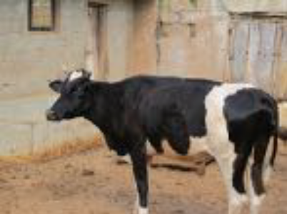
The chickens and vegetable garden provide some of the basic food. Once the cow ‘Malala’, has had her first calf, there will also be milk available. - Malala, sounding Swahili, was suggested by a member of Mary’s Collegiate Parish Church after the young Pakistani activist for female education. She is the youngest Nobel Prize laureate. A parish collection paid for this cow. The surplus milk can then be sold to help with the cost of the fees for the girls. The same is already happening with the vegetables, eggs and chicken.

When I arrived in Masasi I was surprised to get such a hearty welcome not only from the Sisters but also from quite a few girls from the hostel standing there singing with bunches of flowers. It was school holidays. I was then told that the girls feel this is their home and want to stay there even in their holidays.

One day they invited me for dinner and we had good discussions. I told them that we want them to work hard to produce good results at school and get a chance to have further education. As is said in Africa: “Educate a women, you educate a family.” A few days later I got 16 letters giving thanks for our friendship.

Another success story is what a young women did with the money I gave her last year to feed her family. She bought a pig as the price for meat is very high. This year when I saw her again she gave me pictures of the sow she got last year and the four half grown up pigs she has now - a reminder of the parable of the talents (Matt. 25.14). It just demonstrates
what people can do with just a little support.

To the school for children with learning disabilities at Lulindi I took the

13
dolls which I had been asked for. Some ladies in the parish kindly made these to be used as teaching aids. The headmaster was most grateful and the children were full of joy and happiness as they ever are.

At one of the Sisters’ nursery school I was pleased to meet the teacher of the 5 - 6 year old children. He told me that he had been a boy there for three years some 20 years ago. It shows the good start in life which the Sisters give the children, as they do to so many people - water and spirit, Life.

Dirk Juttner

************************************************************************

POETS CORNER

A Winter Night

My window-pane is starred with frost,
The world is bitter cold to-night,
The moon is cruel, and the wind
Is like a two-edged sword to smite.
God pity all the homeless ones,
The beggars pacing to and fro.
God pity all the poor to-night
Who walk the lamp-lit streets of snow.
My room is like a bit of June,
Warm and close-curtained fold on fold,
But somewhere, like a homeless child,
My heart is crying in the cold.

Sara Teasdale
14
FACEBOOK FOR THE SENIOR GENERATION
For those people of my generation who do not and cannot comprehend why Facebook exists, I am trying to make friends outside of Facebook but while applying the same principles. Therefore, every day I walk down the street and tell passers-by what I have eaten, how I feel at the moment, what I have done the night before and what I will do later on and with whom. I give them pictures of my family, my dog, and of me gardening, me taking things apart in the garage, me watering the lawn, me standing in front of landmarks, me driving around town, me having lunch and doing what everybody and anybody does every day. I also listen to their conversations, give them the "Thumbs Up" and tell them "I like them".
And it works just like Facebook.
I already have four people following me; two police officers, a private investigator and a psychiatrist.
Mr Anonymous
***********************************************************************************
AND FINALLY …………..
CROSSWORD SOLUTION

ACROSS 1 Scope 4 Edict 9 Apostles 10 Eden 11 Orders 13 Emmaus
15 Cranmer 18 Easter 19 Deacon 21 Stud 22 Cardinal 23 Grill 24 Grace

DOWN 2 Chords 3 Peter 5 Dreamer 6 Cherubs 7 Canon 8 Esteemed
12 Shadrach 14 Chapter 15 Citadel 16 Iconic 17 Angle 20 Elder

Who’s Where in The Warwick Team

Contacts in our partner churches in the Warwick Team include:

All Saints
Revd Diane Thompson (Team Vicar) 492073

St Nicholas
Revd Linda Duckers (Team Vicar) 496209

St Paul’s
Revd Jonathan Hearne (Team Vicar) 419814

15
ST MARY’S CONTACT NUMBERS

Revd Dr Vaughan Roberts (Team Rector) 492909
Parish Office 403940
Doreen Mills (Reader) 494692
Mark Swinton (Acting Director of Music) 403940
Gail Guest (Church Warden) 885421
John Luxton (Church Warden) 07740 046718
David Benson (Deputy Church Warden) 882207
Godfrey Hill 07788 966844

Bell Ringers 492783
1st Warwick St Mary’s Rainbows/Brownies/Guides 403185
Choir 403940
Friends of St Mary’s Choir 07549 534339
Collegium 498851
St Mary’s Scholars 403940
Flowers 857351
Church Guides 403940
Gift Shop 403940
Sunday School 312861
Friends of St Mary’s Church 419991
St Mary’s Guild of Servers 07713 997769
Sidesmen 882207
Churches Together in Warwick 428420
Guild of Ex Choristers gec@stmaryswarwick.org.uk 740181
Tony King (Magazine Editor) 497349

Church Council Members
The Rector, the Reader and Church Wardens
John Adams (Treasurer) 07711 058935
Vicky Bartholomew (Secretary) 403449
David Clark 465081
Grahame Edmonds
Alan Faulkner
Desmond Jack 495795
Gill James (Synod member) 842024
Frances Humphreys 410723
Tony King 497349
Jayne McHale 497106
Joy Nugent (Synod member) 852565
Carol Warren 493940
Alan Wellan 842828

16

