WARWICK TEAM MINISTRY
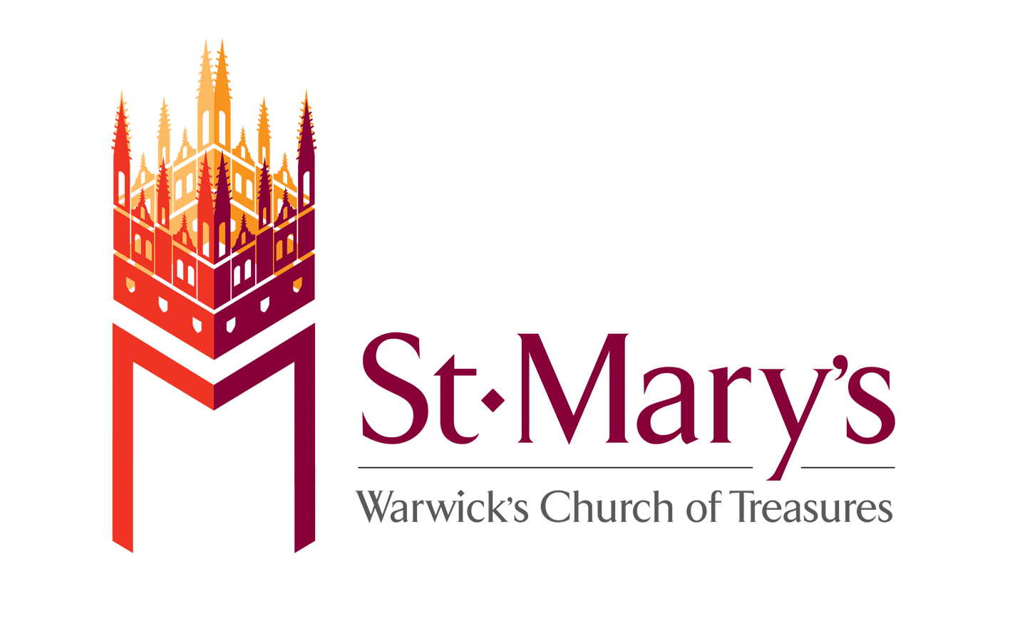

Weekly
Newsletter

WELCOME TO OUR SERVICES. If you are a newcomer to St Mary’s Church, or a visitor to the area, please introduce yourself to one of the sidespeople or the clergy. We hope that you enjoy worshipping with us.
Communicant members of any Christian church are welcome to make their communion with us. If you do not wish to receive communion, but would like to receive God’s blessing, simply hold this service booklet when you come to the altar rail.
St Mary’s seeks to be an inclusive church and welcoming to people of all ages and backgrounds. We have a carpeted area and pew bags available for the youngest members of our congregation, if they wish to use it. And they may like to take an adult with them!

If you’re a UK tax payer the money you place in the collection can be increased by around 25% if you fill out a blue envelope in the nave chairs or by the main entrance and allow us to retrieve the tax you’ve already paid & put it towards the work of St Mary’s.
Further information about St Mary’s, our life and ministry can be found on the website www.stmaryswarwick.org.uk, on Twitter and Facebook.
Please note that for legal and copyright reasons the taking of videos, photographs and recordings is not permitted during services.

May 13th
Easter 7
8.00am Holy Communion (BCP Said)
Celebrant & Preacher: Vaughan Roberts
The service begins in the Book of Common Prayer page 294
The collect and readings begin on page 194

Followed each third Sunday by breakfast at a local café
10.30am Choral Eucharist
Common Worship: Order 1
Boys’ and Men’s Voices

Celebrant & Preacher: Alycia Timmis
Reading: Acts 1: 15-17, 21-end – Alycia Timmis
Intercessor: Tony Fitzpatrick
Assistants: Janet Newbery & Richard Warren

6.30pm Choral Evensong (BCP)
Boys’ and Men’s Voices

Hymn: 486
Preces: Clucas
Psalm: 147: 1-12
Reading: Isaiah ch. 61 – Tony King
Magnificat: Collegium Regale Howells
Reading: Luke 4. 14-21 – Peter Briggs
Nunc dimittis: Collegium Regale Howells
Responses: Clucas
Anthem: Benedicite in G Jackson

Hymn: 443
Preacher: Doreen Mills
Hymn: 476
Organ voluntary: Prelude in C Bairstow

Director of Music: Oliver Hancock
Assistant Director of Music: Mark Swinton

NOTICES

THIS SUNDAY … is a first Sunday of the month and we welcome the The Rt Revd John Stroyan, Bishop of Warwick, who will be confirming a number of candidates from St Mary’s and two others from local churches at a 10.30am Choral Eucharist. Please note that we won’t be having our usual first Sunday pattern of Family Service and Choral Matins.

LAST SUNDAY … we had our Annual Meeting after the 10.30am service. John Luxton & Gail Guest were re-elected as our Churchwardens and David Benson & Godfrey Hill were re-elected as Deputy Wardens. The 2017 accounts were approved and our PCC re-elected. Thank you to everyone who’s worked so hard during past twelve months of St Mary’s ministry and to everyone who came along.

LOOKING AHEAD: As people may know our curate, Alycia Timmis, is due to be ordained priest in Coventry Cathedral on Sunday 1st July. Amongst other things, this means that she will be able to preside at the Eucharist. The first time she’ll be doing that is the following Sunday (8th) and that will be followed by a bring-and-share lunch in The Rectory Garden. Alycia will be taking the Family Service on Sun 3rd June and we will be exploring aspects of what ordination means but there won’t be a Family Service on 1st July, so people can attend Alycia’s ordination in the cathedral.

WARWICK FESTIVAL 2018…we will once again be taking part and are looking forward to hosting a WRITING WORKSHOP to reveal the legend of Guy of Warwick, between 2 and 4pm on Sat 26th May. Come along and hear the story of Guy and Felice brought to life by Jenny Heap, local writer and poet. Then write your own story or poem or even create a picture. At 4.30pm the budding authors and artists will perform their stories and poems and meet some special visitors Guy of Warwick & Friends. Tickets £3 per child (age range 5 – 13) accompanying grown up FREE. A perfect opportunity for adults to take a leisurely tour of our magnificent church, steeped in the country’s history. Have a cup of tea/coffee and homemade cake in our Pop up Café and finish by hearing the children’s tales of a daring knight! To book please email admin@stmaryswarwick.org.uk
‘GUY IN THE SKY ‘– the iconic tower of St Mary’s will also be open for the Festival. Climb the 160 steps to see amazing views over Warwick and the surrounding countryside and the places associated with Guy and other historic landmarks, participate in our quiz and earn a prize. £3 per adult, children FREE, Family ( 2 adults and up to 4 children) £6. Subject to weather conditions.
ST MARY'S SHARED BREAKFAST
Apple Tree tea rooms 12th May 8.45 -10.00 am / 10.30 am
St Mary's shared breakfast group & Apple Tree tea rooms.
As a reflection of the presence of St Mary's in the community, the toilets at our monthly meeting place have been twinned. The owners were very supportive of this joint venture and chose to sponsor facilities in Nepal and Afghanistan.

VOLUNTEERS’ EVENSONG: We shall be giving thanks to God for the work of the tremendous teams of volunteers at St Mary’s on Pentecost Sunday (20th May). If you volunteer here in any way, please do come along.

ACCOMODATION REQUIRED Do you, or does someone you know, have a ‘granny flat’/annex/basement accommodation that needs a tenant? If so, the Director of Music would like to hear from you! We are considering plans for a future Organ Scholarship and are exploring accommodation options. Please contact Oliver Hancock (dofm@stmaryswarwick.org.uk)

FLAG OF ST GEORGE … thanks to some very generous donations from David & Sonia Guest, Wednesday morning communion group and an anonymous donation we have been able to purchase in total four flags at today’s prices to enable us to continue flying the flag for another couple of years.

REST IN PEACE: We are sorry to learn about the recent death of Patrick Wilson, former churchwarden here and great supporter of St Mary’s. His funeral is on Tue 22nd May at 2pm in Oakley Wood.

FRIENDS OF ST MARY'S - SOME DATES FOR YOUR DIARY
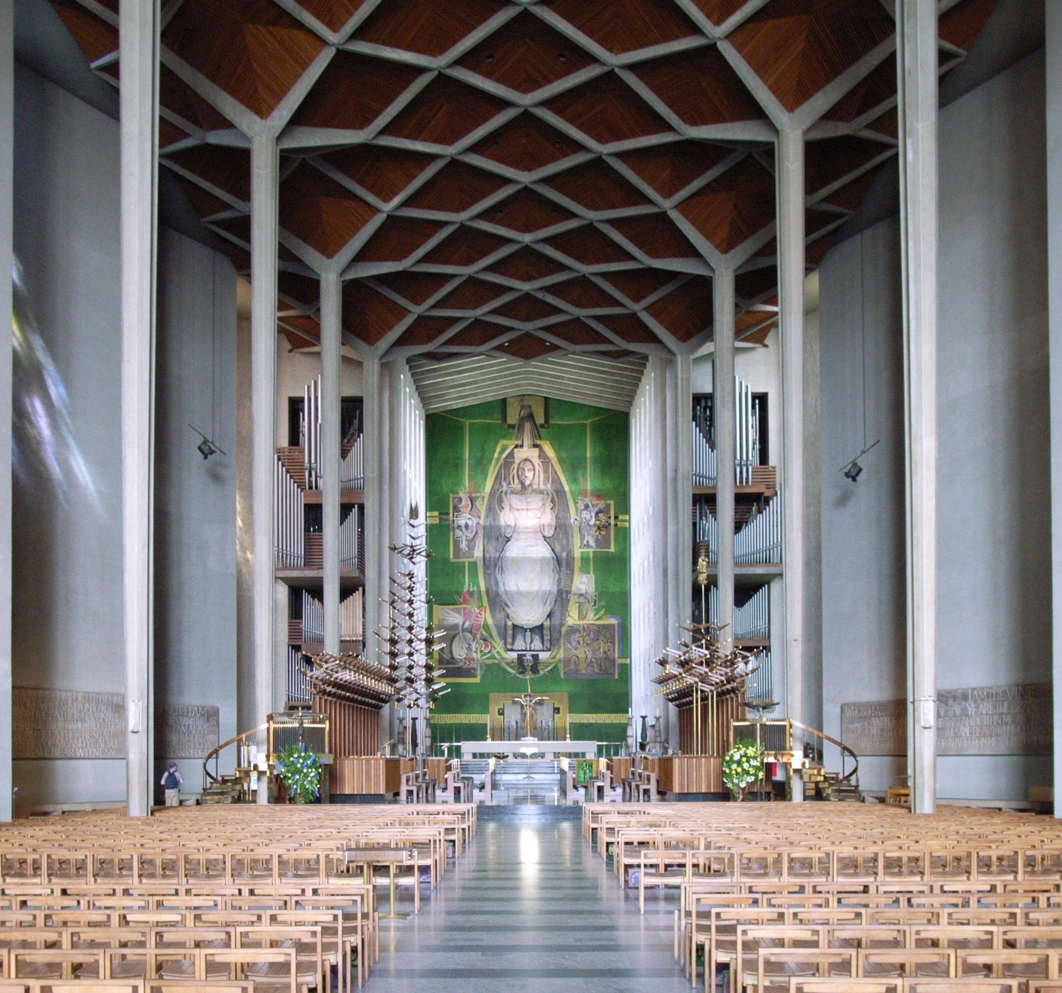
At our AGM last Sunday, it was announced that, due to lack of support, the proposed lecture about Coventry Cathedral and Sir Basil Spence on 23rd May had been cancelled.
Trip to Coventry Cathedral and The Herbert: subject to sufficient numbers (25 - 30 people) the proposed trip Coventry Cathedral and The Herbert on 29th Jun will go ahead. If you are interested please complete a booking form ASAP. Closing date Sun 3rd Jun 2018. (Booking forms available on the reception desk)

BIBLE READINGS
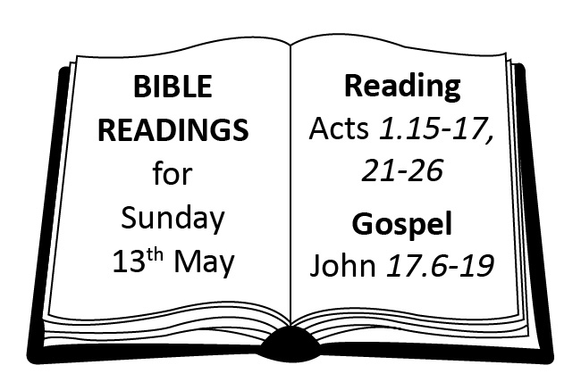
PRAYER OF THE WEEK
Heavenly Lord,
We pray for those who are to be Confirmed as your disciples this weekend.
Guide and bless them, as they commit themselves to Gods work on earth,
And continue to live the promises made at Baptism.
Bless all candidates and give them strength, determination, and patience,
So they are focused on their own spiritual development
and are able to give support to those who are not yet ready to walk with Christ.
Surround them with your love, Lord,
On this special day and always. Amen

SPIRITUAL FORMATION COURSE
The Spiritual Formation course continues this term with the dates, topics and speakers detailed below. The course runs on alternate Thu afternoons at St Michael’s Budbrooke from 1.15 to 3.15 and Thu evenings at St John the Baptist, Berkswell from 7.30 to 9.30. It is possible to pick and mix venues. The cost is £34 for all six sessions or £7 per session. More details contact Chris Edmonds on c.m.edmonds@btinternet.com or Zoe Bell on zoebell@berkswellchurch.org.uk
May 17th The Spanish Mystics Rev Mary Lodge
June 7th Meister Eckhart Rev Paul Edmondson
June 21st Thomas Merton Rev Mark Bratton
July 5th Brother Roger & the Taize Community Rev Keith Mobberley
July 19th Spiritual Formation and New Monasticism Rev Craig Groocock

DAVID BRINDLEY: Vaughan’s predecessor as Vicar of St Mary’s went to be Dean of Portsmouth. His final service before retiring as Dean will be on Sun 10th June with formal farewells at 6pm. Friends from Warwick are warmly invited along.

NEW CHURCH MAGAZINE …
… for May/June is now available at the back of church — at 50p a great read!


MESSY CHURCH WOODLOES starts on Sat 12th May 10.30am-12.30pm at Woodloes Primary School. It will be monthly on the 2nd Sat of the month (excluding August). Messy Church aims to: a) Mission an unreached area of Warwick; b) Provide an opportunity for whole families to engage with faith. We are looking for people to join our volunteers to fulfil the following roles:
• Prayer support
• Welcome & registration team
• Catering & refreshments team
• Craft, story and worship leaders & helpers
• Set up or clear up team
• Distributing leaflets on the Woodloes estate
We are asking volunteers to be available between 9.30am-1pm on the Sat of Messy Church and available for a monthly follow up meeting depending on what role they are undertaking.

Lunchtime recitals
CHURCHES TOGETHER EVENTS
Saturday 19th May HOTS (Healing on the Street) 10am to 12noon. If you would like to join them come along and see how it works.

HOME FOR GOOD
People around Warwick are joining in the national ‘A mile for every child’ campaign this summer to highlight the needs of children in care. Home for Good is hoping that a total of 35k miles will be covered around the country – a mile for every child who enters the UK care system each year. Come along on Sat 23rd June to Warwickshire Golf & Country Club, Leek Wootton. Registration is in the Health Club foyer from 10.30am - the walk starts at 11am. More information: jamesrose@homeforgood.org.uk or 07968 850348

ARDEN VALLEY BENEFICE - BIBLE READATHON
At 1pm on the 11th June someone at St James the Great, Snitterfield will open a Bible and start reading the book of Genesis. The aim is to read the entire Bible out loud in one session, lasting approximately 75 hours. Why are we doing it?
First, it’s a clear and visible expression of our Christian faith. Secondly, we hope to bring people together from across the benefice and diocese to complete the Readathon and to celebrate the Centenary of the Diocese of Coventry. Thirdly, we are planning to raise funds to support two overseas charities, Tariro in Zimbabwe and the Butterfly Tree Charity in Zambia. If you would like to take part, either alone or as part of a group, please see the poster at the back of church for more information.

SUPPORTING THE MUSIC OF ST MARY’S
We are very proud of the musical tradition at St Mary’s. If you would like to support the music-making here we would love to hear from you. It might be sponsoring a service of Choral Evensong in memory of a loved one, or offering a contribution towards the cost of a set of music for the Choir, or sponsoring a concert/recital/something else! Please contact the Director of Music if you can help: dofm@stmaryswarwick.org.uk

VISIT St Mary’s Gift Shop
Cards for every Occasion & Gifts in Stock
CD’s, Trays and Candles, St Mary’s Tea Towels & Notelets
St Mary’s Gift shop can supply stamps at normal price but buying them from the shop gives the church a small profit.

ECCLESIASTICAL INSURANCE …
… celebrates its 130 year anniversary of insuring Anglican churches. They are making a ‘thank you’ offer to donate £130 to the church each time anyone from the church family – clergy, church workers or volunteers take out a home insurance policy with Ecclesiastical during the next year. When an insurance policy is taken out, by quoting Trust 130 & nominating St Mary’s, Ecclesiastical will make a £130 donation. If you’d like a quotation visit www.ecclesiastical.com/Trust130 or call 08007830130 quoting Trust130

PRAYERS FOR THOSE WHO ARE ILL: Flo Carpenter, Christopher Browne, Clifford Browne, Mandeep Madar, Jack Dixon, Gwen Shilton
PRAYERS FOR THE DEPARTED: Trevor Owen, Patrick Wilson, Margaret Walker, John Thompson

THIS WEEK: Beginning 6th May
Wednesday 9th | 10.00am  5.30pm | Holy Communion  Choral Evensong
Thursday 10th | 7.00am  7.30pm | Tower Service  Choral Eucharist
Friday 11th | 5.30pm | Choral Evensong

FORTHCOMING SUNDAY SERVICES

Sunday 13th May – Easter 7
8.00am  Holy Communion | 10.30am  Choral Eucharist | 6.30pm  Choral Evensong

Sunday 20th May – Pentecost
8.00am  Holy Communion | 10.30am  Choral Eucharist | 6.30pm  Volunteers’ Choral Evensong

Sunday 27th May – Trinity Sunday
8.00am  Holy Communion | 10.30am  Choral Eucharist | 6.30pm  Choral Evensong

3rd June – Trinity 1
8.00am  Holy Communion | 9.30am  Family Service | 11.00am  Choral Matins | 6.30pm  Choral Eucharist

Parish Office: (01926) 403940
Felicity Bostock – parishadministrator@stmaryswarwick.org.uk
Glynis Nixon - admin@stmaryswarwick.org.uk

